FUNCTIONAL OUTCOME IN C2/C3 FRACTURE DISLOCATION MANAGED WITH COMBINED SURGICAL DECOMPRESSION AND POSTERIOR STABILIZATION

Teuku Nanta Aulia, Muhammad Iqbal, M Irfan Guranda
Faculty of Medicine, Syiah Kuala University/Dr. Zainoel Abidin Hospital, Banda Aceh, Indonesia
Email: teukunantaaulia@yahoo.co, iiqbalmd@gmail.com,
m.irfanguranda95@gmail.com
Keywords:  Dislocation Fracture; Spinal Cord Injury; Functional Outcome. | ABSTRACT  Spinal cord injury is one of the main reasons for permanent paralysis and immobility till now. Spine injury is usually fatal because it involves more than one component, such as discoligamentous misconfiguration, vascular and spinal cord damage. Spine dislocation fracture at the level of C2-3 is rare and usually affects one or two vertebras. Good functional outcome in spine injury is uncommon in which death almost always happens suddenly or is caused by secondary trauma. Emergency room with a cervical spine injury. The patient was pushed by his friends from the side during playtime, causing the neck to hit the corner of a table. The dislocation fracture at the level of C2-3 and spinal cord compression directly caused tetraplegia. The condition was handled with a decompression procedure, spine fusion at the level of C1-4, and posterior stabilization with pedicle screws. A day after the operation, minimal movements were seen in both arms and legs, with motoric strength of 2/2/2/2. The score improved to 4/4/4/4 after two weeks of meds and physiotherapy. The patient started to write again in week 3. The dislocation fracture in this patient caused spinal cord compression. A retropulsion fracture fragment can be displaced to the spinal canal and potentially cause further spinal cord damage. Displacement towards the anterior horn leads to motoric dysfunction. Dislocation fracture at the level of C2-3 hinders neurotransmitter impulse, causing total paralysis on all extremities with intact sensory function. The patient had temporary external stabilization around the neck area while waiting for the procedure. The management concept in cases like this includes affected spinal cord decompression and internal fixation using pedicle screws to ensure fracture stabilization.
Info Article

INTRODUCTION
Spinal cord injury is a serious medical condition that usually leads to death and permanent disability. It is caused by the disruption of axon nerves inside the spinal cord, affecting both motoric and sensory function below the level of the impacted vertebra. Most spinal cord injuries happen due to significant trauma and primary irreversible injury in people under 30 years old (Tindle & Tadi, 2022). In America, around 17.500 new cases are reported annually. The total case in Asia remains unclear. In a 2019 study in Saudi Arabia, spinal cord injury incidence reaches 38 per 1 million (Alexander et al., 2019). One of the most common injuries found is dislocation fracture. Subluxation is commonly seen in lower segments, from C4 to C7, and only 24% of cases happened above C4.
Dislocation injury at the level of C2-C3 is infrequent (Kiessling et al., 2019). However, regardless of the type, total recovery to condition pre-injury is hard to achieve. One of the symptoms is complete or incomplete tetraplegia or paraplegia. Considering the severe consequences of this kind of injury, it is crucial to perform a thorough evaluation, especially in polytrauma and cervical spine trauma that potentially cause stroke in posterior circulation or cervical trauma accompanied by fracture and dislocation. Bad progression of symptoms can still happen despite being asymptomatic. Patient's condition evaluation becomes hard since there's no agreed algorithm used in deciding therapy approach.
Generally, subaxial injury classification encompasses neurological clinical outcome scoring, trauma morphology, discoligamentous integrity and neurology status. If the patient scored less or equal to three, the patient could be managed conservatively. However, a surgical procedure must be done if the score is more significant than five (Mehdar et al., 2019).
Cervical spine fracture can be handled with external fixation using orthosis or halo fixation, decompression procedure and internal fixation, depending on fracture type, instability and spinal cord compression degree. The primary purpose of the operation is to decompress the nerves' structure and to stabilize the injured vertebra segment. This approach allows the patient to do early mobilization, support recovery while healing other injuries, provides rehabilitation, and facilitates daily activities adaptation faster (Abdelgawaad et al., 2021). Outcomes from spinal cord injuries vary, but injury around the cervical segment is usually more severe with higher mortality risk than other segments due to its risk of damaging the phrenic nerve and respiratory centre. Moreover, secondary injury can cause systemic shock, spinal shock and hyperthermia that contribute to the clinical course and hinder recovery (Mattiassich et al., 2017).
This case study reports a case of a 17 years old male patient with a dislocation fracture at the level of C2-C3 that came in with a complaint of tetraplegia in the emergency room 7 hours before being admitted to the hospital after the neck was hit to the corner of the table.

METHODS

Using the case study method.

RESULTS AND DISCUSSION
Case Presentation
A 17 years old male came in due to his inability to move all extremities (tetraplegia) for 7 hours before hospital admission. The patient was referred from the regional hospital with a history of cervical spine injury and motoric dysfunction right after the incident. At first, the patient played with his friends, then he got pushed, and his neck was hit on the corner of the table. Shortly afterward, the patient couldn’t get back on his feet. The patient was diagnosed with dislocation fracture C2/C3 with spinal cord compression, causing the tetraplegic symptoms.

Figure 1. X-Ray finding showing C2-C3 Figure 2. 3D CT-Scan showing C2-C3 dislocation fracture dislocation fracture
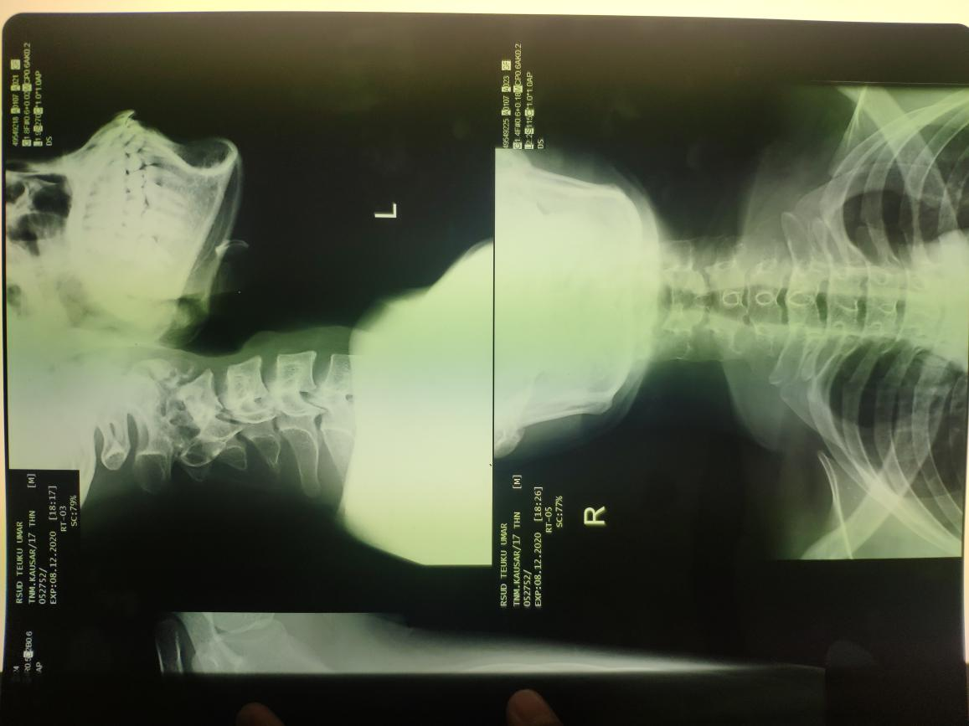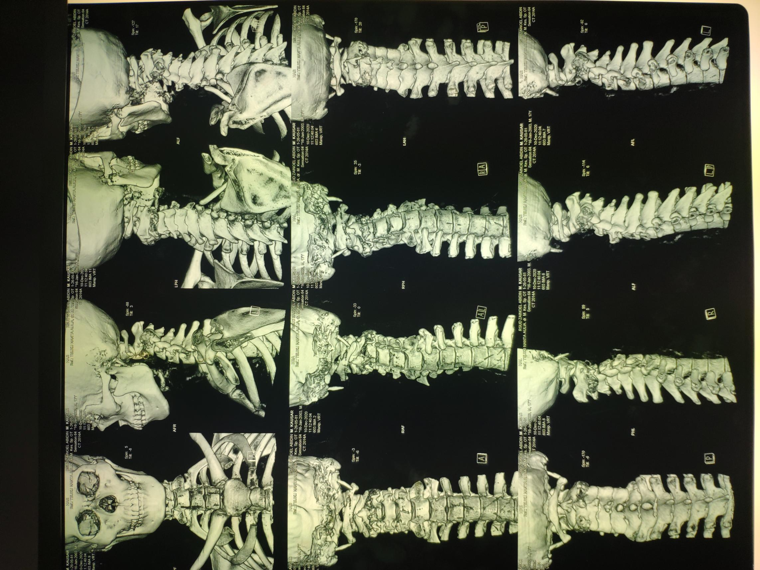

Figure 3. MRI Findings [A] Sagittal View [B] Axial View showing spinal cord compression

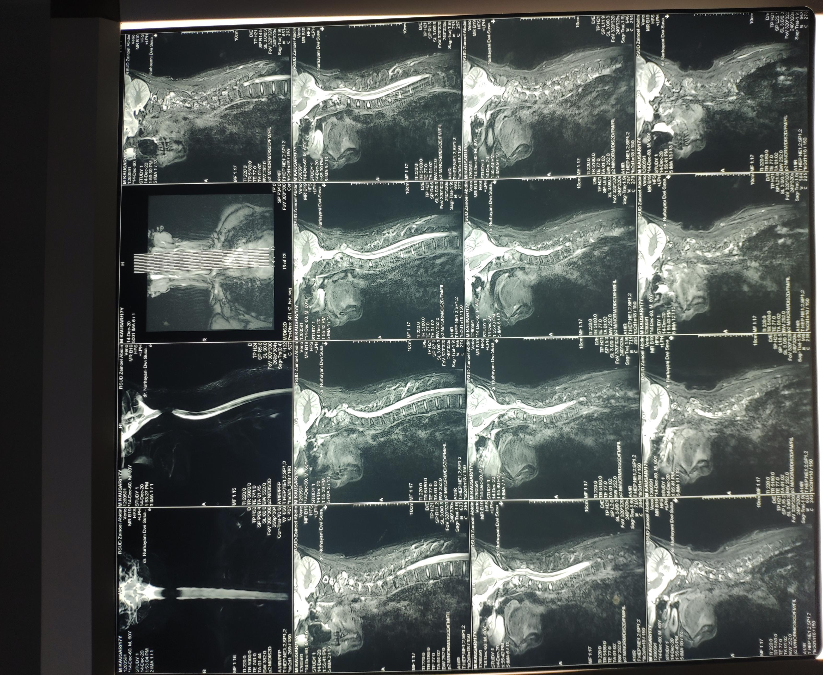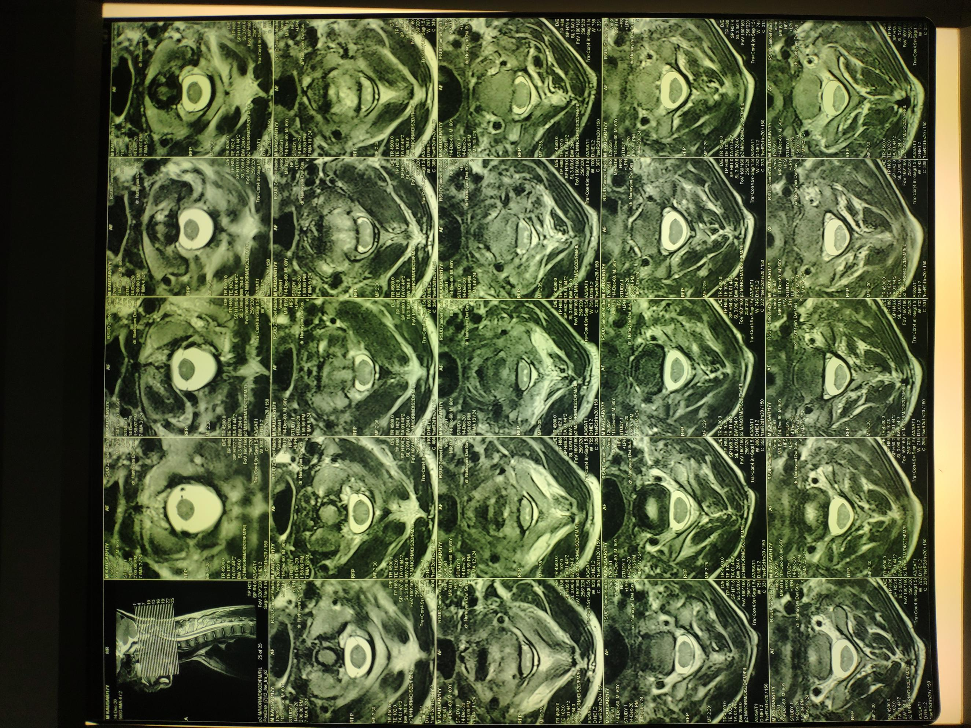
B
A

This patient was managed through a decompression procedure and cervical spine fusion at the level of C1-4 with posterior stabilization using a pedicle screw. A day after the operation, the patient successfully moved both legs and arms with motoric strength of 2/2/2/2. Moreover, the patient also did physiotherapy. Two weeks after the procedure, the patient improved motoric function, evaluated by the increased motoric power from all 2s to 4/4/4/4. Three weeks later, the patient started to write again. During the three-month follow-up period, the patient could do daily activities independently. A longer follow-up period is needed for further evaluation.

Figure 4. Radiology Findings [A] Anteroposterior and [B] Lateral after Decompression Procedure and Posterior Stabilization using Pedicle Screw
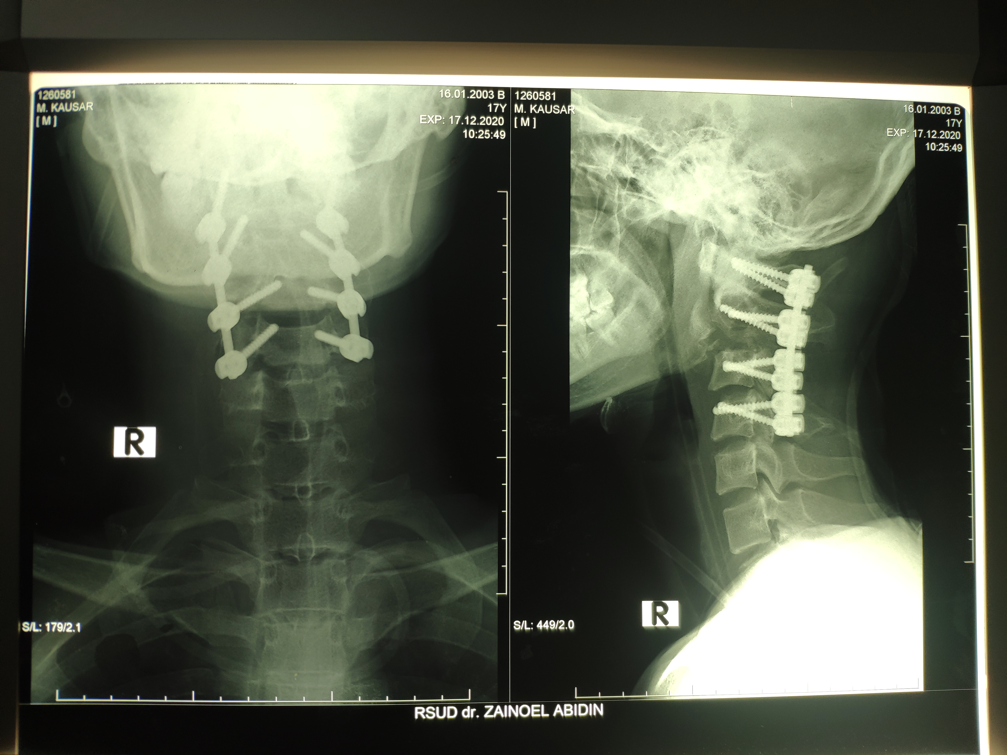
A
B

Figure 5. Functional Outcome during 3 Months Follow-Up

Discussion
Cervical spine injury usually happens on the upper segment, connection junction between C1-C2 or C5-C6. This study reported a traumatic event on a 17-year-old patient with a dislocation fracture at the level of C2-C3. The patient's age group is not considered typical and is no longer included in groups vulnerable to this injury type. Generally, the pediatric population is more prone to this injury due to high ligament laxity. There are only a few similar case studies, as the condition usually leads to sudden death. One case found in children was linked to dislocation during birth. Another case in a 57-year-old patient was connected to a laminectomy procedure he underwent, causing mild neurologic symptoms. It's hard to compare this case study to previous issues because of the different age groups and absence of vascular injury (Kalafat et al., 2016).
The patient came in with motoric dysfunction in all extremities with an American Spine Injury Association (ASIA) score of B, indicating no sensory dysfunction under the lesion level (Otsuka et al., 2021). A previous study mentioned that around 50% of patients with B scores would experience changes in motoric strength, especially in lower extremities and sensory perception. Functional outcomes heavily depend on location and injury severity degree. Generally, injuries on C1-C3 with A-C scores tend to depend on others to perform daily activities and need ventilation to preserve respiratory function (Guest et al., 2022). However, it didn't happen in our patient due to a different mechanism, trauma course, and adequate management. The best clinical outcome was observed in patients who underwent decompression under 24 hours, although there's no consensus agreeing on the best time for operation in spinal cord injury (Alizadeh et al., 2019).
Like other patients with cervical spine injury fractures, it is best to stabilize the neck area using a stiff collar in a neutral position to prevent mobilization and ensure the spinal column stays in line to avoid unnecessary movement. Anamnesis regarding type, mechanism and clinical course is beneficial in diagnosing and identifying primary injury and therapy approach. CT Scan examination also helps evaluation, specifically in the unconscious patient. ATLS algorithm and neurological examination are performed to score patients using ASIA classification, which helps create a more detailed management approach. X-Ray radiology was done in this case; however, whenever possible, CT-Scan is preferable because it gives out a better structural visualization, especially in transitional areas like craniocervical and cervicothoracic (Beeharry et al., 2021). The patient, in this case, report, underwent three radiology examinations; X-Ray, CT-Scan and MRI. MRI remains the gold standard for spinal cord injury because its finding helps predict neurological outcomes (Rutges et al., 2017). MRI also should be performed if conventional radiology and/or CT-Scan resulted in the suggestive discovery of ligament injury and/or dislocation, similar to this case (Kumar & Hayashi, 2016). MRI offers several advantages, such as higher picture resolution, multiplanar imaging and various sequences needed in this condition evaluation. Worse neurological outcomes were seen with oedema and hematoma on the spinal cord (Alkadeem et al., 2021). The patient's MRI showed compression on the anterior horn, so the patient was scheduled for a decompression procedure.
A more precise outcome prediction can be made 72 hours after the primary injury. Another important aspect of predicting prognosis is identifying whether the damage was complete or incomplete. Spinal cord injury patients will have shown functional ability improvement in the first three months before hitting a plateau in month 9. However, a complete recovery can take up to 12-18 months. Patients' recovery with incomplete tetraplegia is better, but sometimes it only happens in the lower level from the injured area. Similar to what's done in this patient, motoric function improvement can be evaluated from motoric strength moments after trauma and is linked with better neurological outcomes (Alizadeh et al., 2019). Other factors associated with patient's betterment are age, comorbidity and social environment (Investigation, 2021).The reported patient is relatively young and healthy with no other comorbidity, which might explain the observed well-functional outcome.
A dislocation fracture in this patient caused spinal cord compression until the anterior horn, eventually causing motoric dysfunction. This goes with the primary injury mechanism concept that commonly happens in spine dislocation fractures. This kind of injury can affect ascending and descending impulse transport, and disrupt blood flow and cell membrane, leading to spinal shock, systemic hypotension, vasospasm, ischemia, ionic imbalance and neurotransmitter accumulation or exotoxicity (Alizadeh et al., 2019). Anterior spinal cord compression at the level of C2-C3 in the patient hindered neurotransmitter impulse transport and caused total paralysis in all extremities without any sensory dysfunction. Like the theory, a lesion on the anterior horn will disturb the motoric system from the neck to the feet (Louis & Richards, 2018). A retropulsion of a fracture fragment can be displaced towards the spinal canal, causing more injury. The condition can be worse with discoligamentous and vascular injuries around it.
The purpose of temporary external stabilization is to maintain the traumatized neck area stability and is a part of operation preparation. This maneuver goes along with the first cervical spine dislocation fracture principle: decompressing the spinal cord and ensuring permanent stability using pedicle screws via a posterior approach. The pedicle screw can hinder spinal growth in kids. Still, it can be done considering its effect on decreasing fixation and fusion degree, superior biomechanics structure, support fusion rate and reducing the need for external fixation. However, the risk of complications can't be eliminated. The posterior approach is preferred over the anterior to minimize infection and other complication risks associated with a tracheostomy (Zeng et al., 2022). Till now, there has yet to be a consensus recommending either approach as long as the primary objectives of decompression are achieved. Other factors influencing the therapy approaches include changes in bone structure, nerve compression and symptoms (Jung et al., 2020). The management of the reported patient went along with other C2-C3 cases that experienced multiple column instability, considering a heavier burden on the anterior side (Alexander et al., 2019). The affected spinal cord decompression operation will fix the motoric impulse transport peripherally so the motoric function can be regained.
Physiotherapy is also needed to optimize the patient's motoric function to how it was pre-injury. The Sci-Fi study stated five essential aspects to help recover the patient's functional ability: basic mobility, self-care, fine motor, wheelchair mobility and ambulation (Wu et al., 2022). Physiotherapy should be started as soon as possible to build strength and flexibility to support a safe and effective healing process (Gabada et al., 2021). Moreover, early physiotherapy can prevent muscle contracture or permanent shortening of the muscle cell and improve the overall quality of life by supporting cellular signal transport and growth factor expression. In a study on animal subjects, early mobilization increased growth factors such as insulin-like growth factor 1 level and axon regeneration (Badhiwala et al., 2018). There has yet a study that explored the effectiveness of y in cervical trauma cases. Still, it has been proven effective in the reported patient cause after three months of operation and constant physiotherapy, the patient managed to perform daily activities independently

CONCLUSION
A dislocation fracture caused spinal cord compression in this patient. A retropulsion fragment fracture can be displaced into the spinal canal and potentially cause more spinal cord injury. Displacement towards the anterior horn will cause motoric dysfunction. Dislocation fracture on C2/3 hinders neurotransmitter impulse transport, causing total paralysis on all four extremities without sensory dysfunction. A temporary external stabilization around the neck area was needed in this patient. Along with the therapy principle, the approach in this patient is decompression of the affected spinal cord and internal fixation using a pedicle screw for fracture stabilization.

BIBLIOGRAFI
Abdelgawaad, A. S., Metry, A. B. S., Elnady, B., & Sheriff, E. El. (2021). Anterior Cervical Reduction Decompression Fusion With Plating for Management of Traumatic Subaxial Cervical Spine Dislocations. 11(3), 312–320. https://doi.org/10.1177/2192568220903741
Alexander, H., Dowlati, E., McGowan, J. E., Mason, R. B., & Anaizi, A. (2019). C2–C3 spinal fracture subluxation with ligamentous and vascular injury: a case report and review of management. Spinal Cord Series and Cases, 5(1), 4.
Alizadeh, A., Dyck, S. M., & Karimi-Abdolrezaee, S. (2019). Traumatic spinal cord injury: an overview of pathophysiology, models and acute injury mechanisms. Frontiers in Neurology, 10, 282.
Alkadeem, R. M. D. E. A. A., El-Shafey, M. H. R., Eldein, A. E. M. S., & Nagy, H. A. (2021). Magnetic resonance diffusion tensor imaging of acute spinal cord injury in spinal trauma. Egyptian Journal of Radiology and Nuclear Medicine, 52(1), 1–13.
Badhiwala, J. H., Ahuja, C. S., & Fehlings, M. G. (2018). Time is spine: a review of translational advances in spinal cord injury: JNSPG 75th Anniversary Invited Review Article. Journal of Neurosurgery: Spine, 30(1), 1–18.
Beeharry, M. W., Moqeem, K., & Rohilla, M. U. (2021). Management of cervical spine fractures: a literature review. Cureus, 13(4).
Gabada, R. H., Kasatwar, P., & Kulkarni, C. A. (2021). Rehabilitation Strategies in Management of Complex Case of Cervical Burst Fracture- A Case Report. 33, 205–208. https://doi.org/10.9734/JPRI/2021/v33i59A34265
Guest, J., Datta, N., Jimsheleishvili, G., & Gater, D. R. (2022). Pathophysiology , Classification and Comorbidities after Traumatic Spinal Cord Injury.
Investigation, O. (2021). Effect of Early vs Delayed Surgical Treatment on Motor Recovery in Incomplete Cervical Spinal Cord Injury With Preexisting Cervical Stenosis A Randomized Clinical Trial. 4(11), 1–13. https://doi.org/10.1001/jamanetworkopen.2021.33604
Jung, Y. G., Lee, S., Jeong, S. K., Kim, M., & Park, J. H. (2020). Subaxial cervical pedicle screw in traumatic spinal surgery. Korean Journal of Neurotrauma, 16(1), 18.
Kalafat, U., Akman, C., & Topacoglu, H. (2016). Complete dislocation at the level of C2-C3 vertebra with vertebral artery rupture in a multitrauma patient. Int J Med Sci Public Health, 5, 590–592.
Kiessling, J. W., Whitney, E., Fiani, B., Khan, Y. R., & Mahato, D. (2019). C2-3 fracture dislocation and bilateral vertebral artery occlusion without neurological injury: a case report. Cureus, 11(8).
Kumar, Y., & Hayashi, D. (2016). Role of magnetic resonance imaging in acute spinal trauma: a pictorial review. BMC Musculoskeletal Disorders, 17(1), 1–11.
Louis, R., & Richards, A. (2018). TREASURE ISLAND. B JAIN Publishers PVT Limited.
Mattiassich, G., Gollwitzer, M., Gaderer, F., Blocher, M., Osti, M., Lill, M., Ortmaier, R., Haider, T., Hitzl, W., & Resch, H. (2017). Functional outcomes in individuals undergoing very early (< 5 h) and early (5–24 h) surgical decompression in traumatic cervical spinal cord injury: analysis of neurological improvement from the Austrian Spinal Cord Injury Study. Journal of Neurotrauma, 34(24), 3362–3371.
Mehdar, K. M., Mahjari, A. A., Al Rashah, A. A., Alyazidi, A., & Mahjri, A. A. (2019). Epidemiology of spinal cord injuries and their outcomes: a retrospective study at the King Khalid Hospital. Cureus Journal of Medical Science, 11(12).
Otsuka, T., Maeda, Y., Kurose, T., Nakagawa, K., Mitsuhara, T., Kawahara, Y., & Yuge, L. (2021). Comparisons of neurotrophic effects of mesenchymal stem cells derived from different tissues on chronic spinal cord injury rats. Stem Cells and Development, 30(17), 865–875.
Rutges, J. P. H. J., Kwon, B. K., Heran, M., Ailon, T., Street, J. T., & Dvorak, M. F. (2017). A prospective serial MRI study following acute traumatic cervical spinal cord injury. European Spine Journal, 26, 2324–2332.
Tindle, J., & Tadi, P. (2022). Neuroanatomy, parasympathetic nervous system. In StatPearls [Internet]. StatPearls Publishing.
Wu, X., Song, Q., Jin, P., & Liu, B. (2022). Outcomes of Patients with Cervical Spinal Cord Injury Treated by Surgery and Their Prognostic Factors. 2022(January 2017).
Zeng, J., Jiang, H., Zhuo, Y., Xu, Y., & Deng, Z. (2022). A case report on a child with fracture and dislocation of the upper cervical spine accompanied by spinal cord injury. Medicine, 101(30).

Copyright holder:
Teuku Nanta Aulia, Muhammad Iqbal, M.irfan Guranda (2023)

First publication right:
Jurnal Health Sains

This article is licensed under the following:

